# CS 255 System Design Document

## UML Diagrams

### UML Use Case Diagram

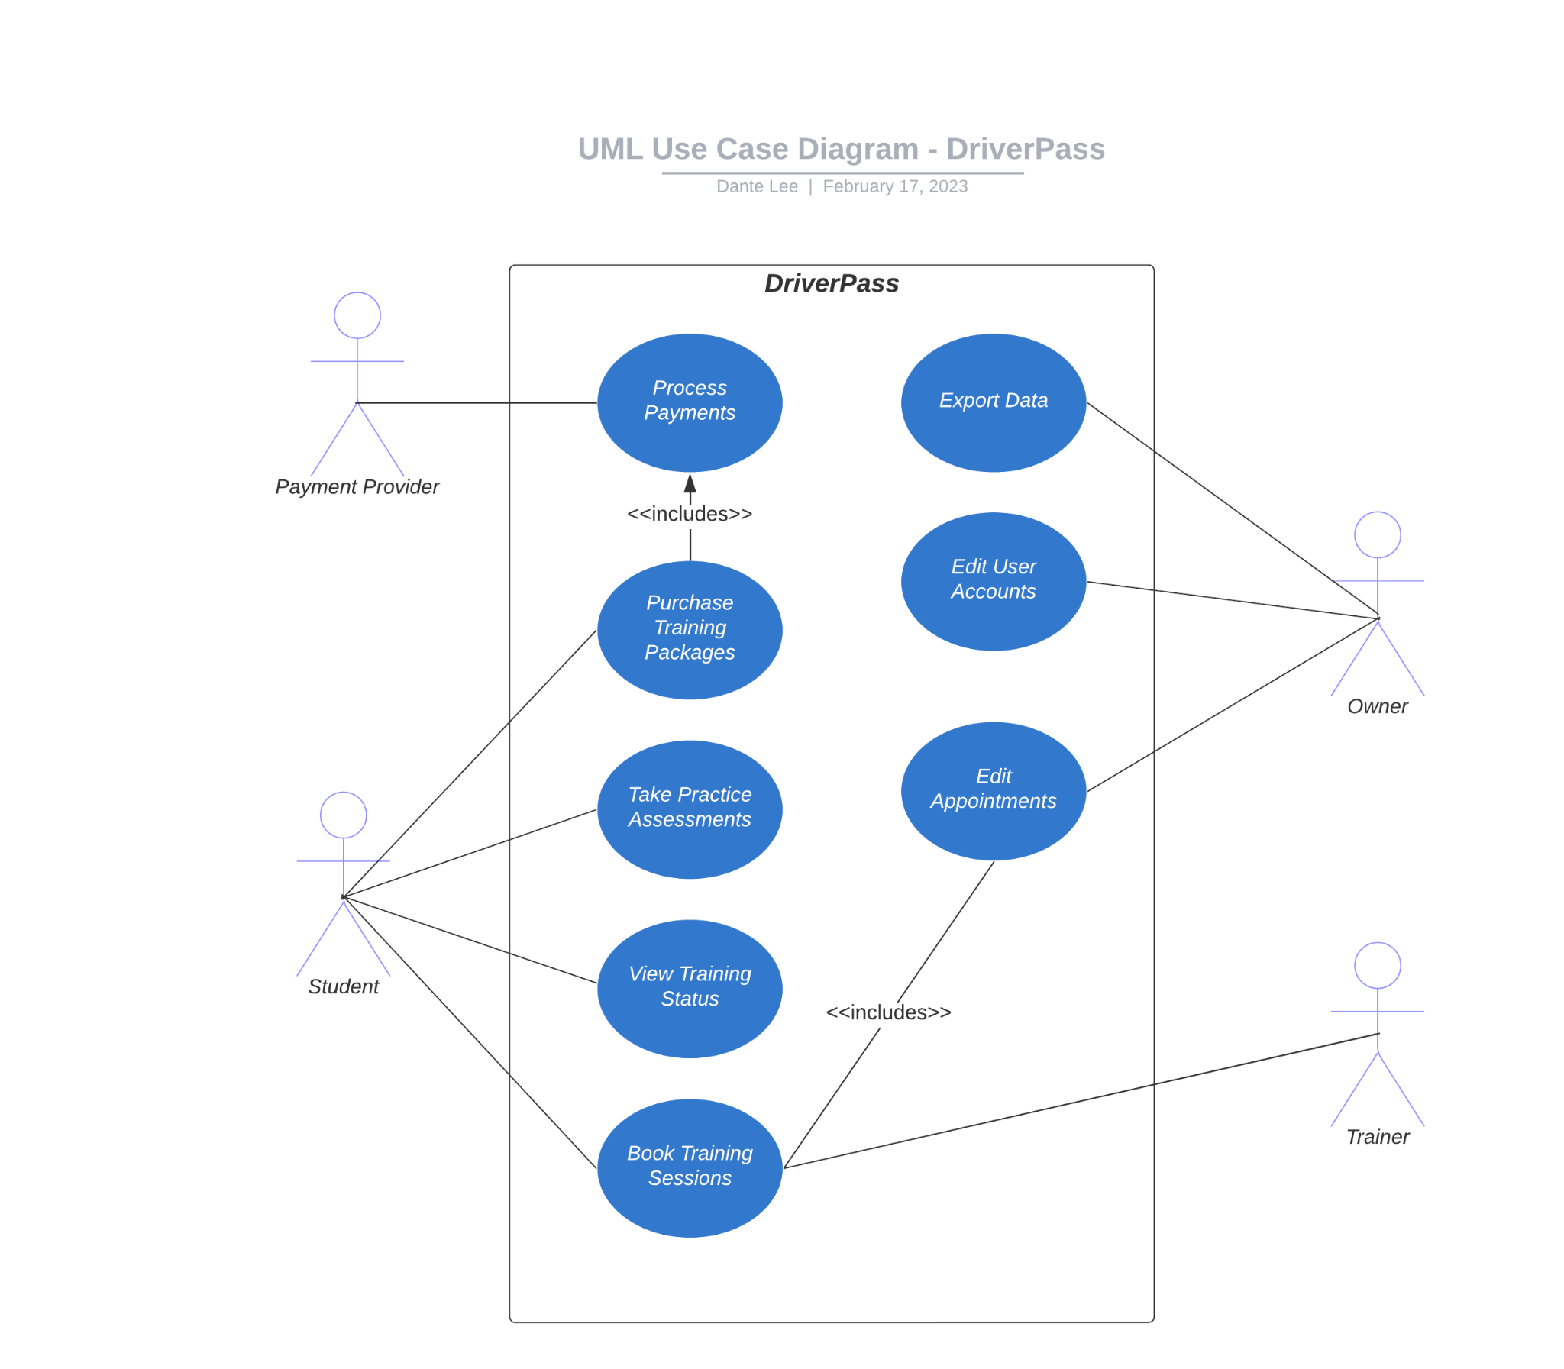

### UML Activity Diagrams

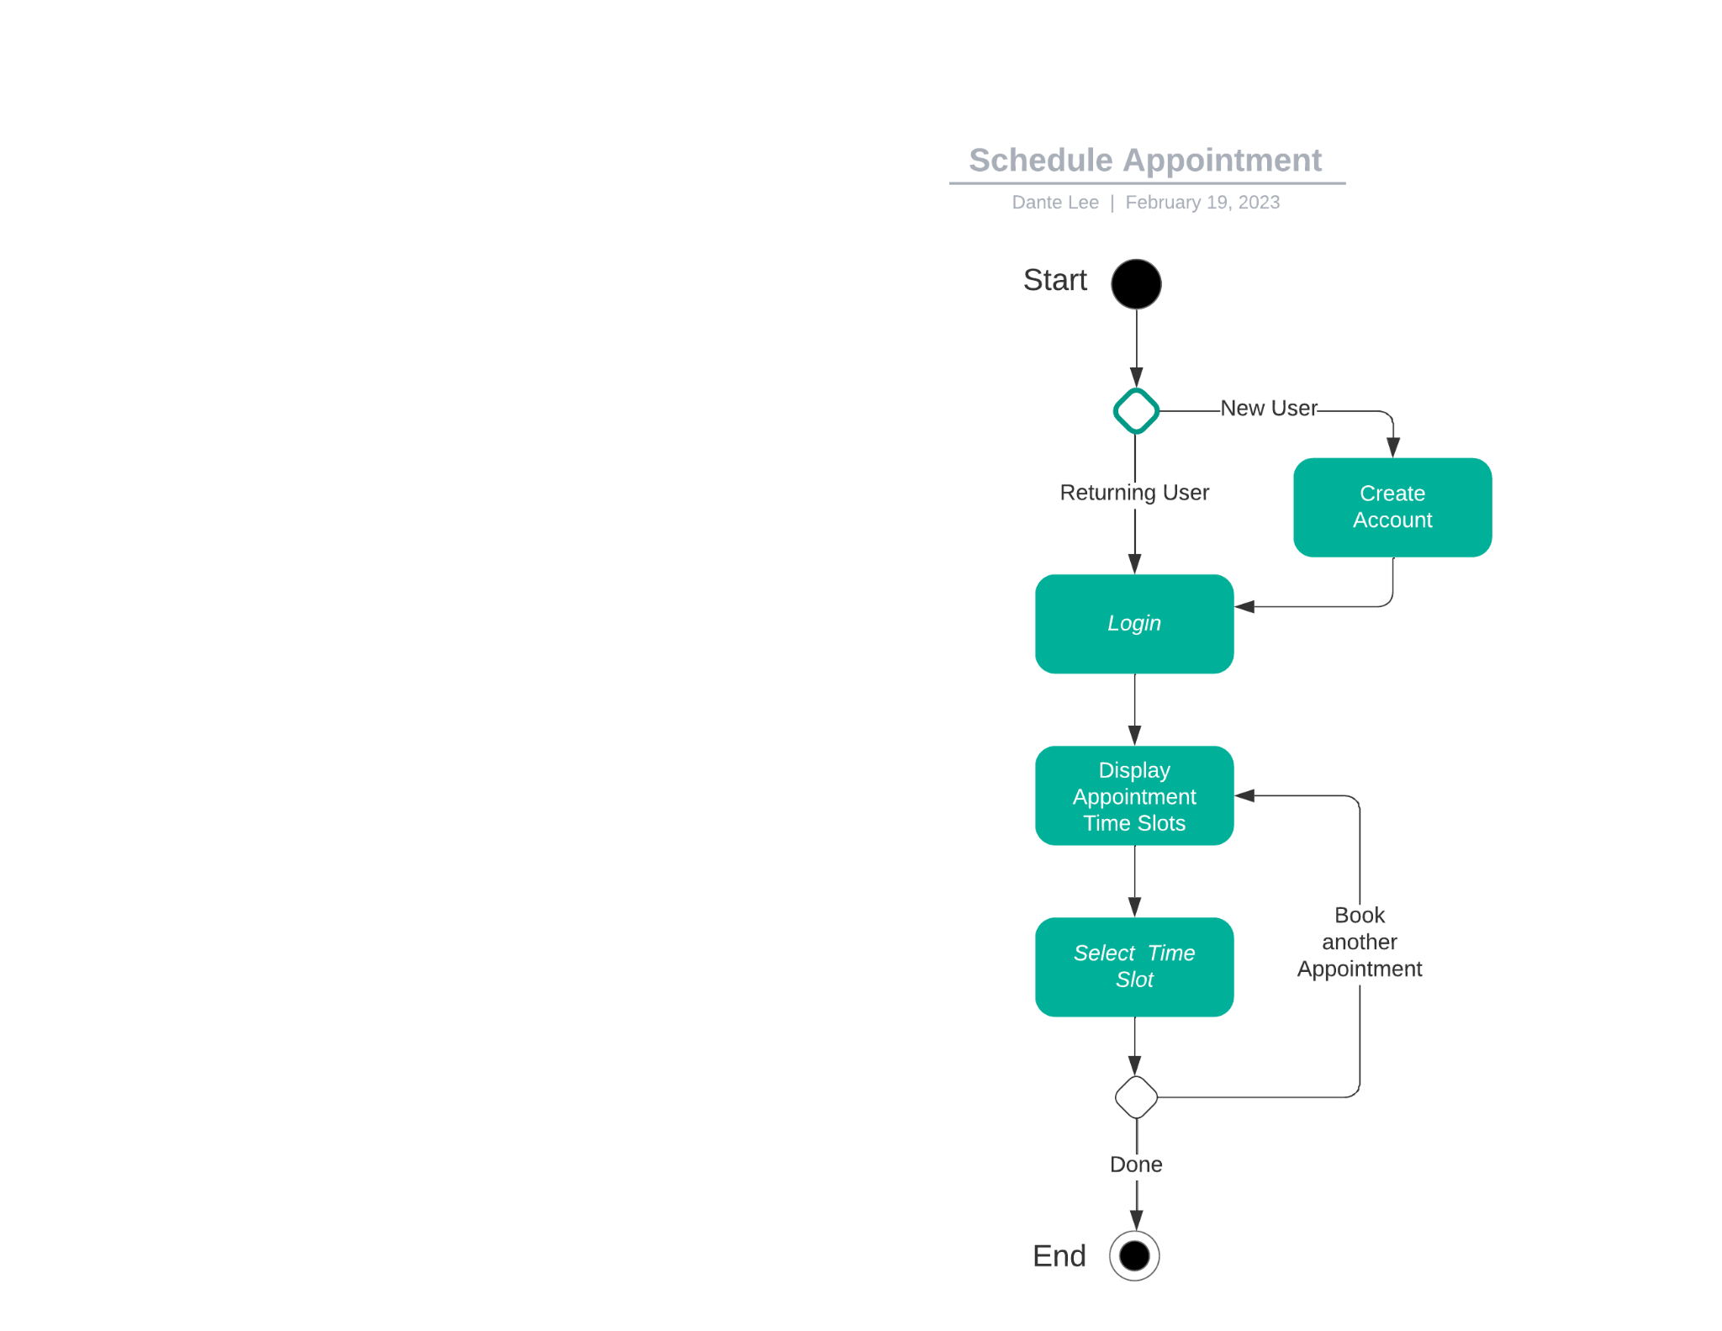

### 

### UML Sequence Diagram

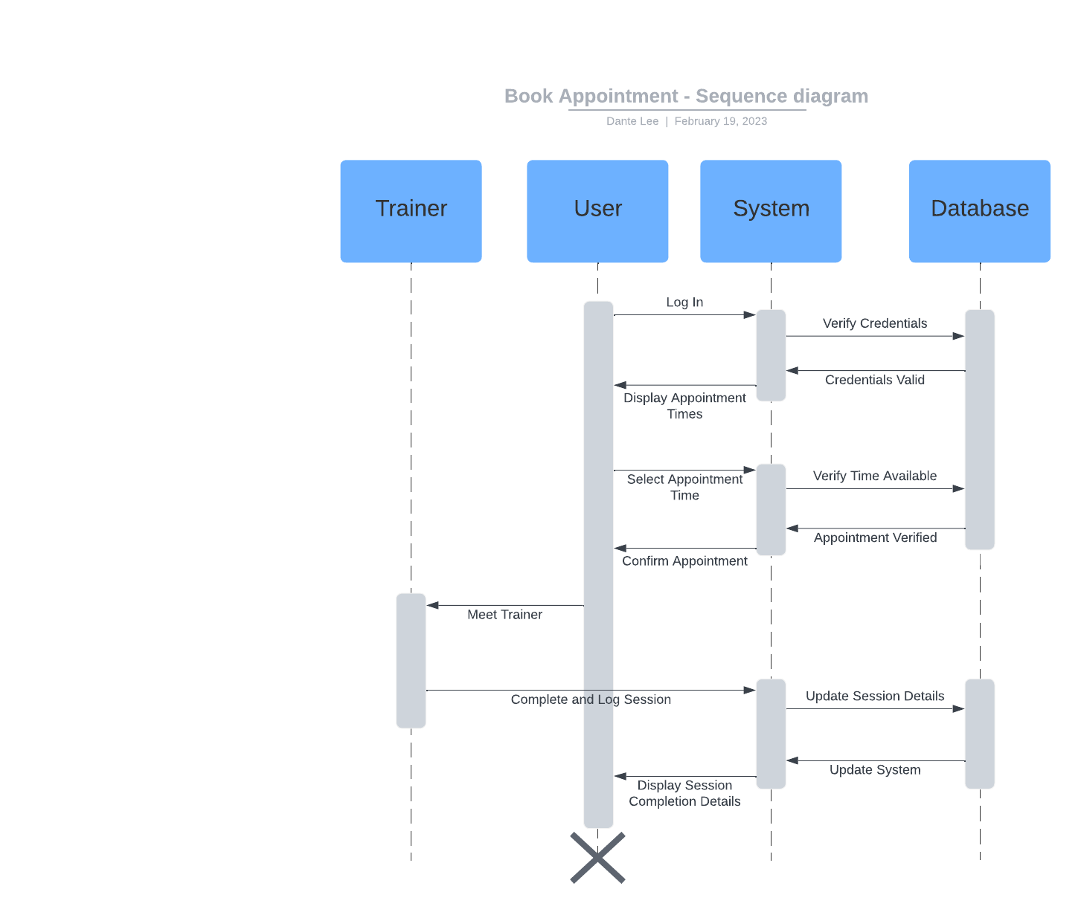

### UML Class Diagram

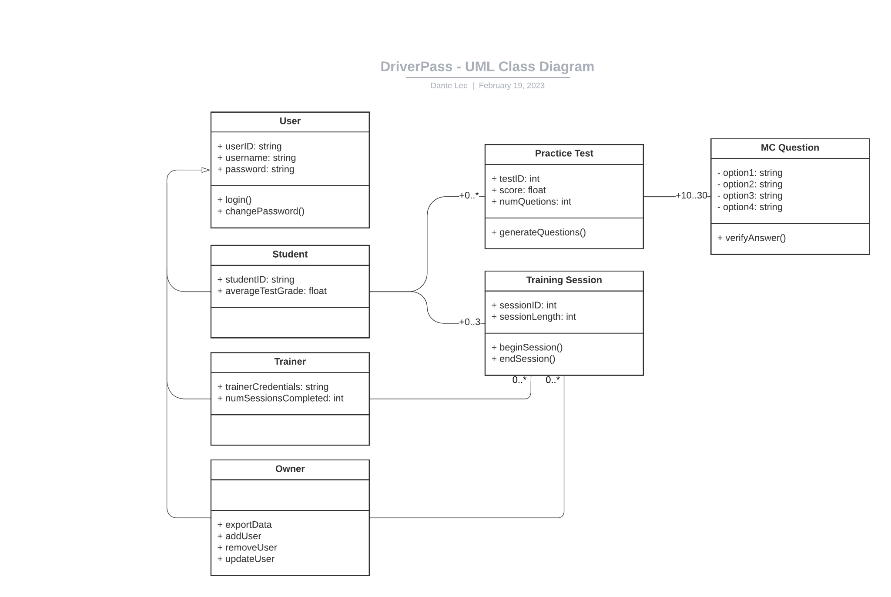

## Technical Requirements

* Web server: the application will be a browser/web based system for all users to interact with
* Database: to store user information such as credentials, test scores, test questions, appointment time slot availability, service data, etc.
* DriverPass will be connected to the DMV for policy updates, any notifications about changes must be received immediately
* Admins should be able to load and export data from the database through the web application
* Different types of user accounts must be available with different permissions
  + Admin/Owner
  + Student
  + Trainer
* Students may be able to contact trainers to coordinate events, so contact information should be available upon booking a session
* Practice tests should be loaded from the database with random questions selected